**HEB-APPLE PAY:**

H-E-B is a supermarket company based in America that has around 340 stores across the U.S. They are a leading private supermarket chain that also owns the ‘Central Market’, which is an upscale organic and fine foods retailer. Apple Pay is a convenient and easy to use contactless mobile payment and digital wallet service launched by Apple Inc. It is a conventional and secure way of payment through devices that have iOS such as iPad, iPhones, etc. It is easy to use, convenient to pay, and quick to transact. Most of the leading organizations accept Apple pay payment method in their shops.

**Does H-E-B take Apple Pay?**

H-E-B currently does not accept Apple pay. It is said that the supermarket giant has the store registers have the technology to accept Apple pay, but it isn’t in working order yet. After reviewing a survey from the customer representatives across various retail stores, customers have conveyed that in some stores Google pay is accepted but Apple pay is currently unavailable for payment. According to a recent survey, almost 52% of Americans use Apple iPhones and the majority of them use Apple pay. Most of the leading retailers in America accept Apple pay. So, when customers who only have 'Apple pay' visit the H-E-B store, the unavailability of Apple pay makes it inconvenient for them to have a stress-free shopping experience.

**Why H-E-B isn’t accepting Apple Pay?**

H-E-B currently accepts debit cards, credit cards, cash, and personal checks in general in their stores. But recently, due to the pandemic, the supermarket giants considered various options to encourage contactless cash transactions or payments to ensure the safety and hygiene of their customers and employees. But even then, Apple Pay, a contactless method of payment, is still not being accepted in their stores. Although we have these problems, sources close to the H-E-B claim that the company is testing a new method of payment. The H-E-B is testing a revolutionary self-checkout application or feature in the stores in San Antonio and New Braunfels. This application helps the user to scan the barcodes in the products and pay through QR codes. Thus, long lines of customers during festive or busy days can be prevented. As H-E-B is ignoring Apple pay for quite some time now, we can understand that they are having a strong motive to make a name for themselves in the field of contactless payments. This not only makes them frontrunners in the technical field but also on a competitive note in the supermarket field. As the customers prefer hassle-free shopping and checkout, such an application or feature will suppress the sales of other supermarket chains which doesn’t have such convenient applications.

**How does it affect Apple pay users?**

As H-E-B is a leading supermarket, most people prefer going to their stores to buy their desirables. But, when Apple pays users who visit there if they don’t take their cards or cash along with them, they can’t complete the payment. This affects people who only use online transactions through Apple pay and don’t use their cards or cash often. As the self-checkout app, namely ‘H-E-B Go’ is still under testing and not rolled out yet for the public to use, it will be a problem for Apple pay users and even Google pay users as only some stores accept Google pay. Although the reason behind the ignorance of payment methods like Apple pay, Google pay, and tap to pay for popularizing or marketing their ‘H-E-B Go’ app, customer representatives say that they would like the supermarket giants to include these payment methods as they are convenient with them at the current moment. In 2020, Apple Pay would be available on 93 percent of US handsets. In recent years, Apple Pay's popularity has skyrocketed in the United States. So, it shows that people prefer using Apple pay more than any other payment option.

**How will this decision affect H-E-B?**

The unavailability of Apple pay may have cost quite a few customers for the H-E-B. As their competitors such as Target, Cosco, etc. allow all kinds of payments including Apple Pay, the customers find them more convenient than H-E-B. Despite the fact that the goal of promoting and popularizing their app is admirable, H-E-B should accept Apple Pay until 'H-E-B Go' is released. According to sources, the company is working to implement Apple Pay in all of its locations as quickly as possible. This will be a relief to Apple Pay users, and H-E-B will be able to reclaim clients who were lost due to Apple Pay's unavailability. Despite these concerns, H-E-B believes that the introduction of the 'H-E-B Go' app goes well, and if it does, people will find H-E-B to be their go-to shop because it takes less time, making them an unstoppable force in the supermarket industry.

**Grammarly screenshot:**

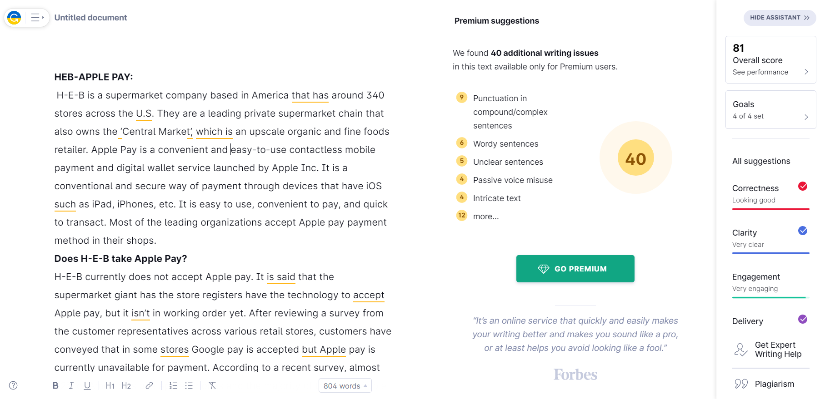

**Spinmenot screenshot:**

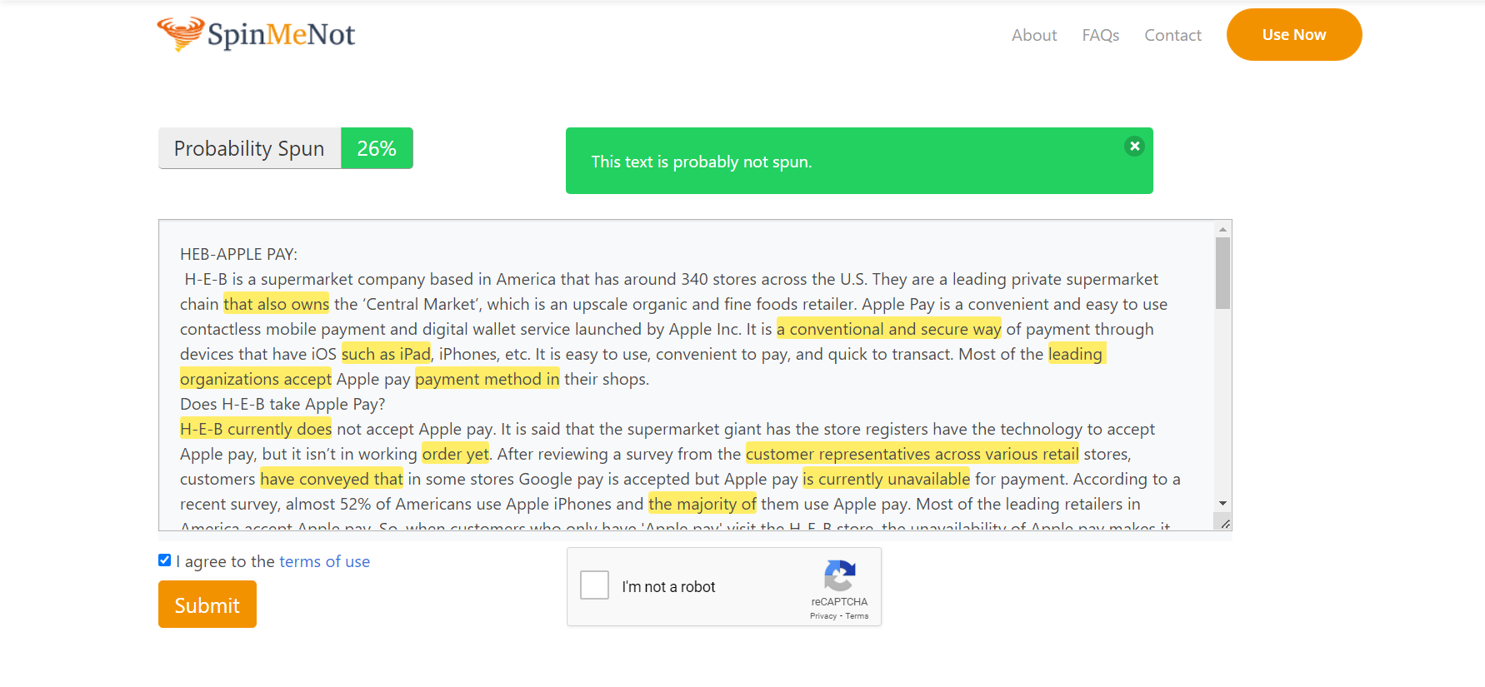

**Quetext plagiarism check:**

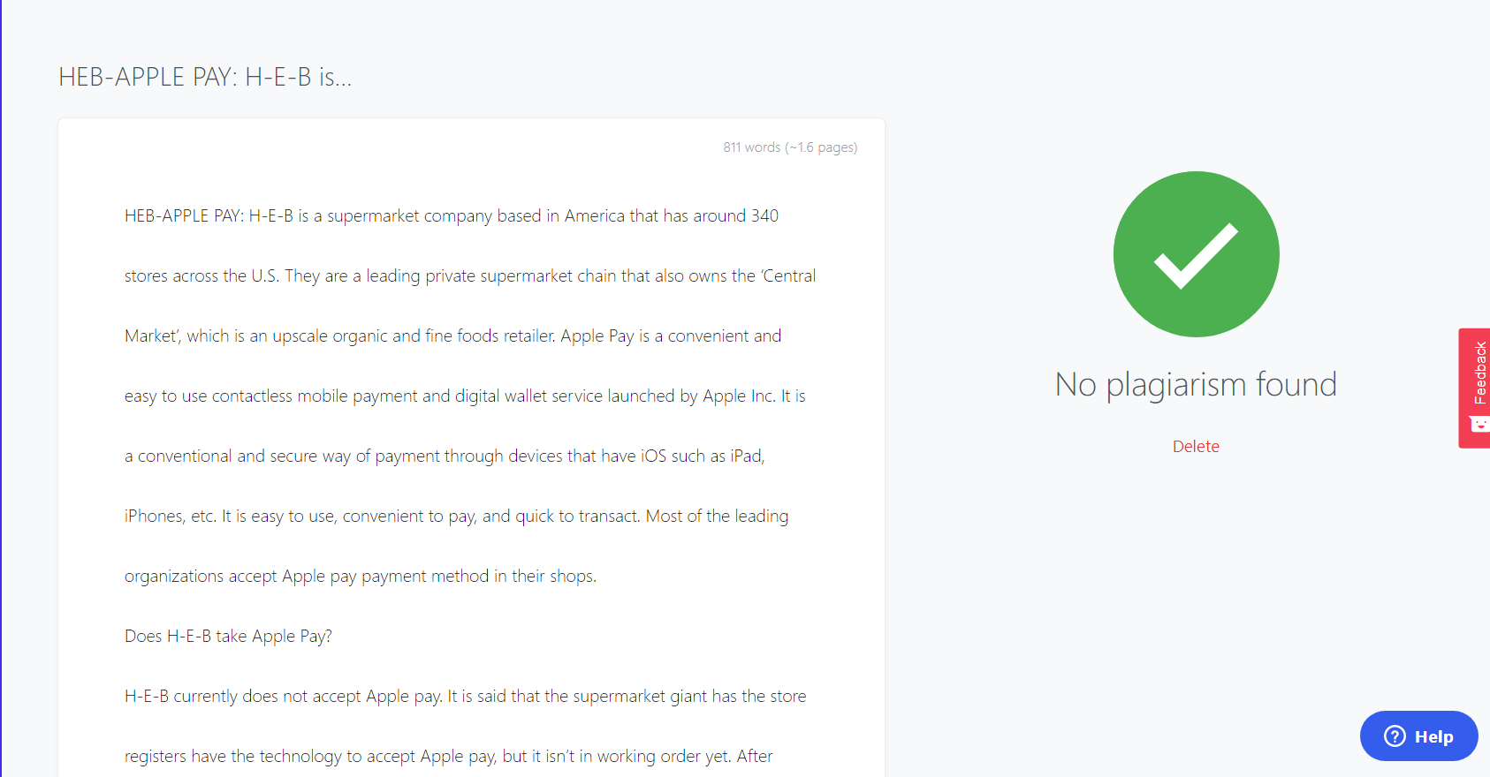

**-Article by Sanjay M**